Image

[RASG-APAC]

Model Advisory Circular

RUNWAY INCURSION PREVENTION AND PILOT TRAINING

RASG Model Advisory Circular Control Information
NOTE
This Model Advisory Circular has been prepared under the authority of the Regional Aviation Safety Group – Asia and Pacific Regions (RASG-APAC)
This Model Advisory Circular has been developed to address the pilot attributed occurrences of runway incursions with a view to reduce the risk of an aviation accident.
National civil aviation administrations should consider this Model Advisory Circular when developing safety-related regulations, information and guidance for their own aviation industry.
A Model Advisory Circular may provide information and guidance purposes. It may describe an example of an acceptable means, but not the only means, of demonstrating compliance with internationally-recognized standards and recommended practices.
A Model Advisory Circular does not create, amend or permit deviations from internationally-recognized standards and recommended practices.
An Advisory Circular issued by a National civil aviation administration should be consistent with its national regulatory framework, regulations and standards.
This page is NOT part of the Model Advisory Circular

Model Advisory Circular
Subject: | Runway Incursion Prevention and Pilot Training
Document Number
Issue number
Issue Effective Date
Valid until date
Approved | [RASG Decision reference, date]
ICAO Secretariat file no.
ICAO Technical Office:
Inform Changes to:

 | Document History
Issue number | Description | Effective

This page is NOT part of the Model Advisory Circular

– Title & Image – NATIONAL CIVIL AVIATION ADMINISTRATION

Advisory Circular
Subject: | Runway Incursion Prevention and Pilot Training
Issuing Office: |  | Document No.:
File No.: |  | Issue Number: | 01
Available from |  | Effective Date:
 |  | Valid until:

Table of Contents
1.0 INTRODUCTION
1.1 Purpose
1.2 Applicability
2.0 REFERENCES AND DEFINITIONS
2.1 Reference Documents
2.2 Definitions and Abbreviations
3.0 BACKGROUND
4.0 ACTION BY STATES
5.0 GUIDANCE MATERIAL
6.0 INFORMATION MANAGEMENT
7.0 DOCUMENT HISTORY
8.0 CONTACT OFFICE
1.0 INTRODUCTION
This Advisory Circular (AC) is provided for information and guidance purposes. It may describe an example of an acceptable means, but not the only means, of demonstrating compliance with regulations and standards. This AC on its own does not change, create, amend or permit deviations from regulatory requirements, nor does it establish minimum standards. This AC is issued in accordance with [applicable national regulatory framework.]
This AC may use mandatory terms such as “must”, “shall” and “is/are required” so as to convey the intent of the regulatory requirements where applicable. The term “should” is to be understood to mean that the proposed method of compliance is strongly recommended, unless an alternative method of safety protection is implemented that would meet or exceed the intent of the recommendation.
1.1 Purpose
The purpose of this AC is to bring to the attention of APAC States the importance of pilot training to reduce the incidence and/or severity of runway incursions. The AC includes information on existing guidance and training material which can be used in the development and implementation of Standard Operating Procedures (SOP) and runway incursion training programmes for pilots. This safety enhancement reduces the risk of Runway Incursions (RI) by the incorporation of RI training and SOP into flight crew qualification, approved training, and other pilot training programmes. This training will increase the pilot’s ability to recognize and avoid situations leading to runway incursions
1.2 Applicability
This document is applicable to all States in the APAC region. It is important that when using the information provided in the reference material, it is modified where required to comply with the existing standards and regulations for that State. For example, several recommended resources provide guidance on aerodrome signage and markings, which are compliant with US FAA regulations, but which may differ from other States.
- REFERENCES AND DEFINITIONS
2.1 The following reference material may be consulted for information purposes:
- ICAO DOC 9870 - Runway Incursion Prevention Manual
- ICAO Doc 4444 - Air Traffic Management
2.2 Definitions and Abbreviations
- The following definitions are used in this document:
- Runway Incursion: Any occurrence at an aerodrome involving the incorrect presence of an aircraft, vehicle or person on the protected area of a surface designated for the landing and take-off of aircraft. (ICAO Doc 4444)
- Local Runway Safety Team: A team comprised of representatives from aerodrome operations, air traffic services providers, airlines or aircraft operators, pilot and air traffic controllers associations and any other group with a direct involvement in runway operations that advise the appropriate management on the potential runway incursion issues and recommend mitigation strategies. (ICAO Doc 9870)
- The following abbreviations are used in this document:
- AC: Advisory Circular
- ACI: Airports Council International
- ANSP: Air Navigation Service Provider
- APAC: Asia Pacific
- APRAST: Asia Pacific Regional Aviation Safety Team
- ATC: Air Traffic Control
- ATS: Air Traffic Services
- CANSO: Civil Air Navigation Services Organisation
- EASA: European Aviation Safety Agency
- FAA: Federal Aviation Administration
- GA: General Aviation
- GASP: Global Aviation Safety Plan
- IAOPA: International Council of Aircraft Owner and Pilots Association
- IATA: International Air Transport Association
- IFALPA: International Federation of Airline Pilots’ Associations
- RASG: Regional Aviation Safety Group
- RI: Runway Incursion
- SEI: Safety Enhancement Initiative
- SOP: Standard Operating Procedure
3.0 BACKGROUND
3.1 ICAO in its Global Aviation Safety Plan (GASP) 2013 continues to prioritize action in three areas of aviation safety – improving runway safety, reducing the number of Controlled Flight into Terrain (CFIT) accidents and reducing the number of Loss of Control In-flight (LOC-I) accidents and incidents. All of these actions will contribute to the overarching priority of the GASP to continually reduce the global accident rate.
3.2 In line with the ICAO GASP, the APRAST Runway Safety Sub Group initiated a Safety Enhancement Initiative (SEI) focused on the development and implementation of SOP and provision of runway incursion training for pilots with a goal of reducing the incidence of runway incursion occurrences and accidents.
3.3 According to FAA data, approximately 65 percent of all runway incursions are caused by pilots, with approximately 75 percent of these attributed to General Aviation (GA) pilots.
3.4 There are a range of factors contributing to pilot attributed runway incursions which can either directly, or in combination with other factors lead to the occurrence. The most common factors are:
- Aerodrome complexity and variations from standard
- Inappropriate, unreadable or lack of airfield signs, markings or lights
- Communications, including:
- Ambiguous and/or misunderstood transmissions
- Traffic and radio congestion
- Human factors, including:
- Physiological factors (e.g. Fatigue)
- Distraction
- Complacency
- Environmental factors, including:
- Weather
- Visibility
- Pre-flight planning of ground movements
- Pilot application of correct rules and procedures
- Pilot training, knowledge and experience; relating to
- Aerodrome markings, signs and lights, and
- Procedures relating to operation on and around runways
3.5 Very few runway incursions occur as a result of a single factor, with the majority resulting from a combination of factors. For example, GA aerodromes which are used for pilot training, are often complex in design and have a lot of traffic and communication. Add to this the factors associated with an inexperienced, or trainee pilot and the likelihood of a runway incursion is significantly increased.
3.6 States should benefit from a significantly reduced incidence of runway incursions and an overall improvement in aviation safety by ensuring the inclusion of runway incursion training for pilots within:
- State-defined syllabi for pilots to achieve and maintain their license;
- Air Operator training, including company SOP, aircraft type-rating and re-current training; and
- Location-specific training, for identified RI threats at aerodromes used by the operator.

3.7 This training should be coupled with;
- The requirement for Air Operators to develop and implement SOP relating to runway incursions; and
- Ongoing surveillance activities by States/Regulators of aerodromes, Air Navigation Service Providers (ANSP), air operators and other organisations that operate on aerodromes.
3.8 As a minimum, pilot training should include:
- Communication/ RT Procedure and phraseology
- Rules and SOP for taxi
- Rules and SOP for crossing, entering or operating on any runway
- The use of a sterile cockpit
- Procedure to ensure the pilot looks outside of the cockpit
- Aerodrome markings, signage and lights
4.0 ACTION BY STATES
4.1 States should enhance aviation safety by:
- Ensuring that pilot licensing syllabi for all level of pilots includes Runway Incursion training;
- Ensuring that Air Operators include runway safety in initial and recurrent training for pilots;
- Ensuring that air operators develop, maintain and implement effective SOP for training of pilots against runway incursions; and
- Ensuring that flight crew use Standard Operating Procedures (SOP) to reduce the risk of runway incursions.
4.2 Although this AC focuses on the provision of RI training for pilots, it is also recommended that States, through their existing regulatory procedures, ensure that runway incursion prevention is considered when reviewing the infrastructure, procedures and training of aerodromes, ANSP and airside vehicle operators.
5.0 GUIDANCE MATERIAL
5.1 The global aviation industry has developed a range of guidance material which can be used either as stand-alone training for pilots, or in the development of RI training and SOP. These resources are available through the ICAO Runway Safety iKit available at http://cfapp.icao.int/tools/RSP_ikit/story.html.
5.2 Appendix 1 to this AC contains a summary of some material available to assist States and organisations to develop or implement Runway Incursion training and SOP for pilots.
5.3 States should note that the guidance material also provides a significant amount of relevant information to assist States, Regulators, aerodromes, pilots, ANSPs and other sectors of industry, to improve the safety performance and efficiency of runway operations, such as unstable approaches, runway excursions and other aspects of aerodrome surface operations.
6.0 INFORMATION MANAGEMENT
(1) Not applicable.
7.0 DOCUMENT HISTORY
(1) Not applicable.
8.0 CONTACT OFFICE
Issued under the authority of:
Name and Title of the person with authority to issue this AC on behalf of the National Civil Aviation Administration. Typically, this would be the Director General
[Name]
[Title]
[National Civil Aviation Administration]
For more information, please contact:
Name and Title of the Technical Office responsible for the subject of this AC
[Name]
[Title]
[National Civil Aviation Administration]
[email]
[phone]
Suggestions for amendment to this document are invited, and should be submitted to:
[Name]
[Title]
[National Civil Aviation Administration]
[email]
[phone]
Appendix 1
RUNWAY INCURSION TRAINING AND GUIDANCE MATERIAL
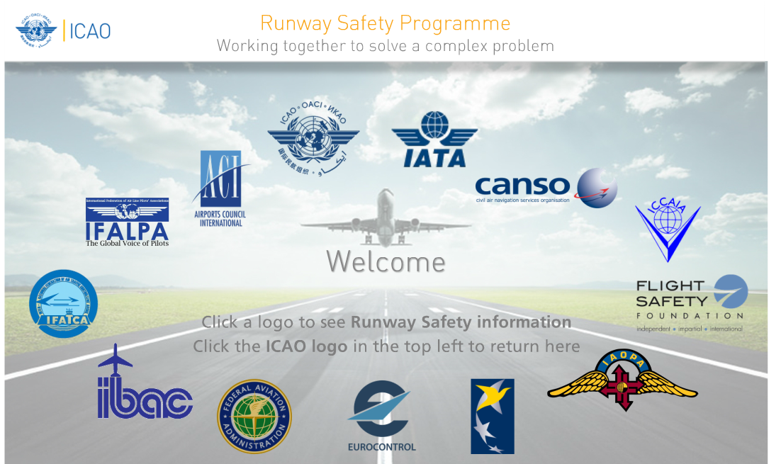
ICAO RUNWAY SAFETY TOOLKIT
(http://cfapp.icao.int/tools/RSP_ikit/story.html.)
The ICAO Runway Safety Toolkit provides a range of information and training products relating to runway safety. Although the products listed below, contain specific material relating to the prevention of runway incursions for pilots, States, ANSP, aerodrome and aircraft operators should consider the use of toolkit when addressing other areas of runway safety, such as runway excursions, airside driving, unstabilised approaches, aerodrome maintenance and communications.
ICAO Manual on the Prevention of Runway Incursions (Doc 9870)
This manual provides runway incursion contributory factors, best practices and recommendations for prevention, as well as guidance for the implementation of national or local runway safety programmes.
ACI Runway Safety Handbook
Although designed for use by aerodrome operators and airside drivers, this booklet includes information regarding aerodrome signage, markings and procedures which are equally as relevant to pilots.
IFALPA Runway Safety Manual
This manual provides information to pilots on aerodrome layout, SOP development and guidance to avoid a runway incursion.

IAOPA Air Safety Institute Runway Safety Online Course
This course takes an in-depth look at safe airport operations, with special emphasis on tricky situations from the real world of cockpit distractions, confusing taxiways, and miscommunication.
Note. To access this course, users will be required to create a user account with AOPA.
IAOPA Air Safety Institute Runway Safety Flash Cards.
These cards contain images and information regarding aerodrome signs and markings. They are suitable for both learning and for testing knowledge of the most common aerodrome signage and markings.
FAA Runway Safety
The FAA Runway Safety page provides a range of information for use by pilots, aircraft operators, training organisations and States relating to the procedures, signage markings and lights and other aerodrome information which could be included in pilot runway incursion training and SOP development. Additionally, the website includes already developed instructional information, tips and information to avoid runway incursions. Examples include:
- New Runway Safety Section for Pilots Handbook of Aeronautical Knowledge
This appendix to the Pilots Handbook of Aeronautical Knowledge provides pilots with an overview of runway incursions and guidance information and best practices relating to taxi planning and procedures, communications and airport signs markings and lighting.
- FAA Taxi Test
This 60-minute video provides a comprehensive look at runway safety best practices including a review of signs and markings; scenario-based do's and don'ts; and clear explanations of why certain procedures are critical.
European Action Plan for the Prevention of Runway Incursions
This document contains a range of recommended actions and guidance for aircraft operators, aerodromes, ANSPs and regulators to reduce runway incursions. Sections also exist on specific topics such as pilot/ATC communications and flight crew best practice to avoid runway incursions.
OTHER RI GUIDANCE OR TRAINING MATERIAL
Airservices Australia Pilots Guide to Runway Safety
(http://www.airservicesaustralia.com/wp-content/uploads/Pilots_Guide_to_Runway_Safety.pdf)
This booklet combines a range of information on aerodrome signage, markings and lights with guidance and tips to pilots regarding safely operating on or around runways.
Australian Tips to Avoid a Runway Incursion (leaflet)
http://www.airservicesaustralia.com/wp-content/uploads/Tips-to-avoid-runway-incursion.pdf
This leaflet was developed by the Australian Runway Safety Group from the most common errors made by pilots leading to a runway incursion. It provides graphical information on common aerodrome signs and markings and tips to pilots to avoid a runway incursion.
FAA Academy Runway Incursion Prevention
This classroom training aims to reduce or eliminate runway incursions by increasing awareness of causal factors. The course covers information on runway safety programs, common RI scenarios and factors, communications, visual aids, best practices for taxi operations and SOP development. The course is available through the ICAO TRAINAIR program (http://www.icao.int/training/Pages/default.aspx).

